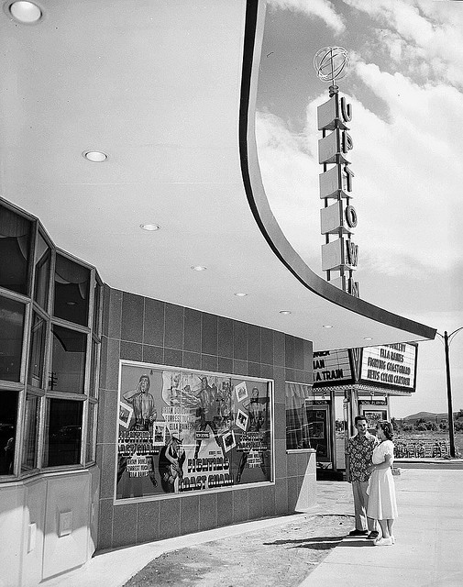
1951, "The Fighting Coast Guard" at the Uptown Cinema
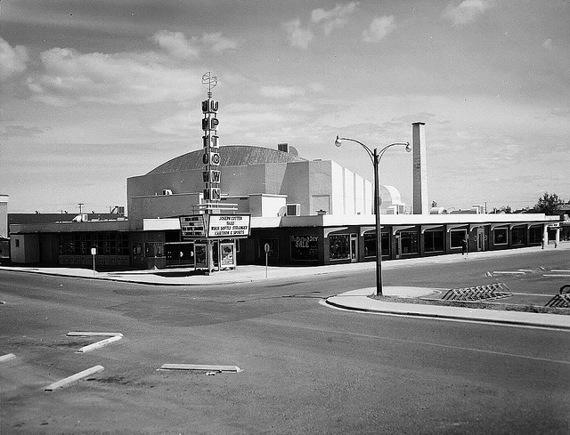Uptown Cinema, 1951
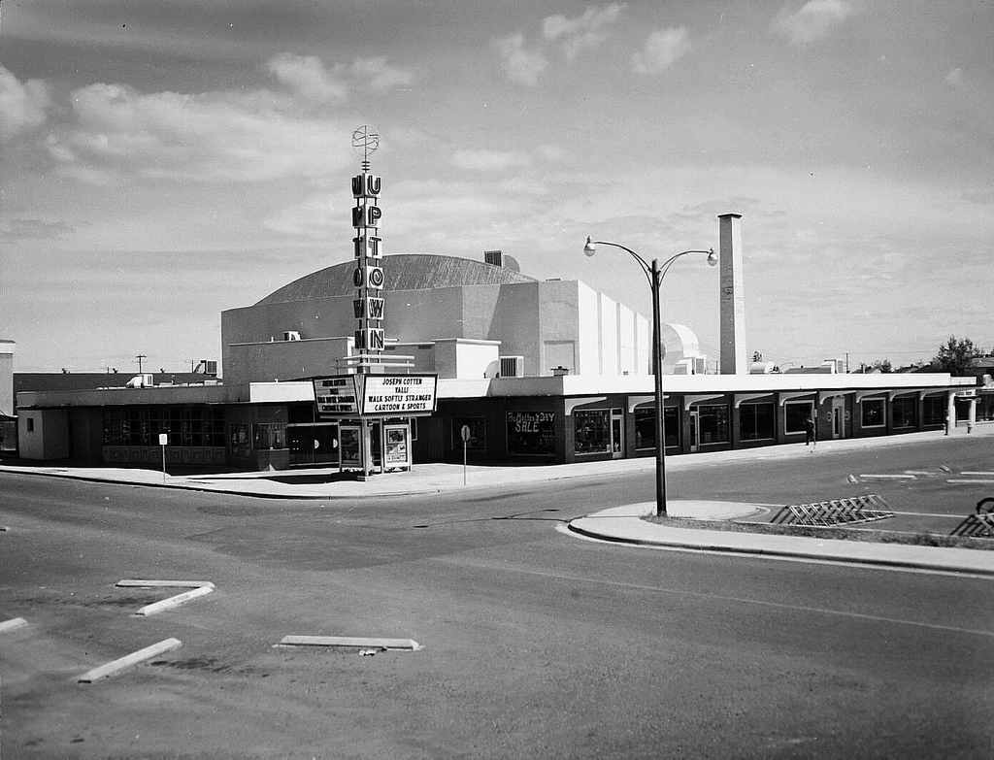
UPTOWN CINEMA 1951
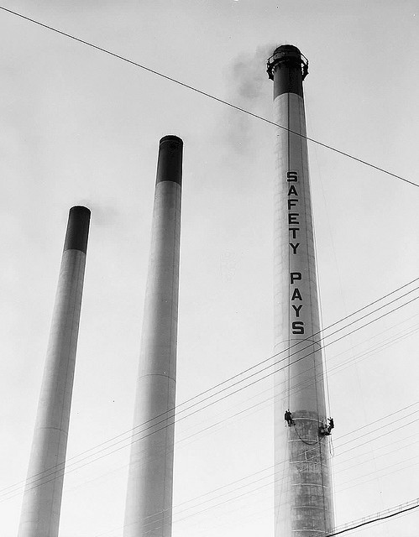

Painting Powerhouse Stacks, 1957
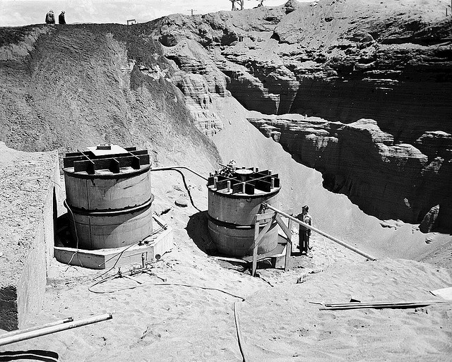

Purex Construction, 1954
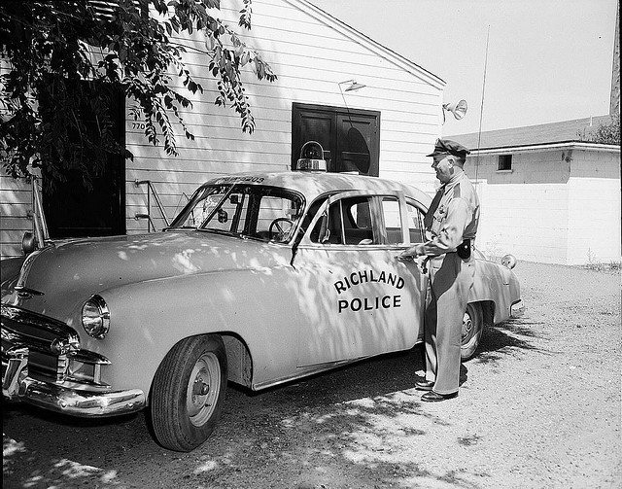

Police 1951
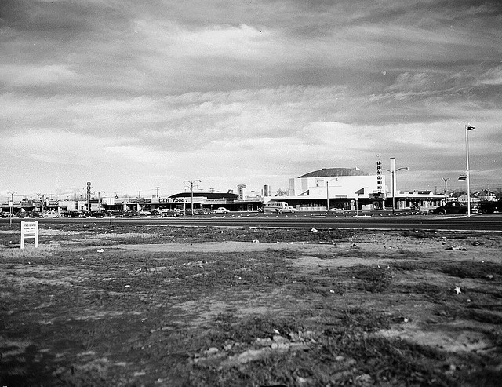

Uptown 1951
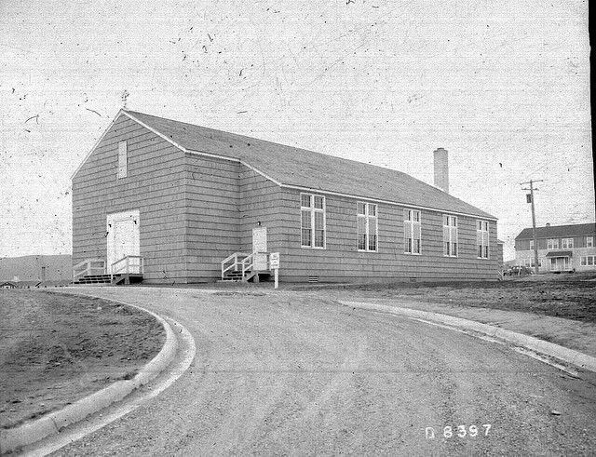

Christ the King Catholic Church, 1945
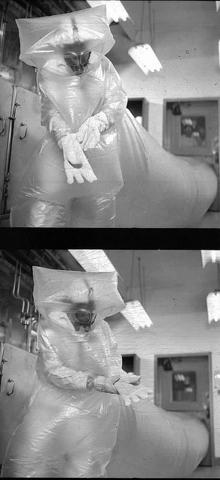

1954 PLASTIC MAN - 231 BUILDING, 200-W
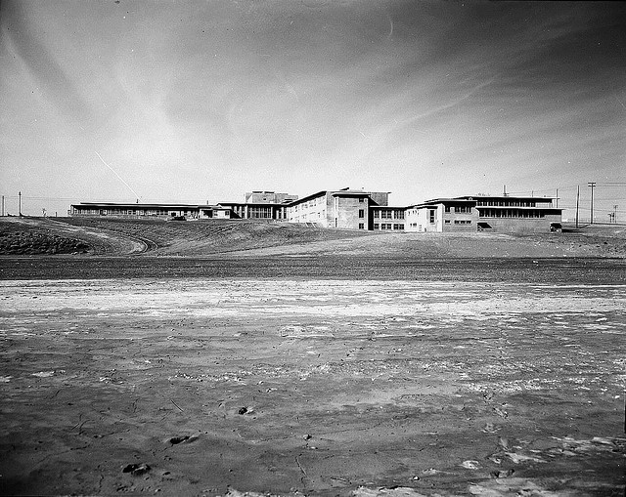

CARMICHAEL JUNIOR HIGH SCHOOL
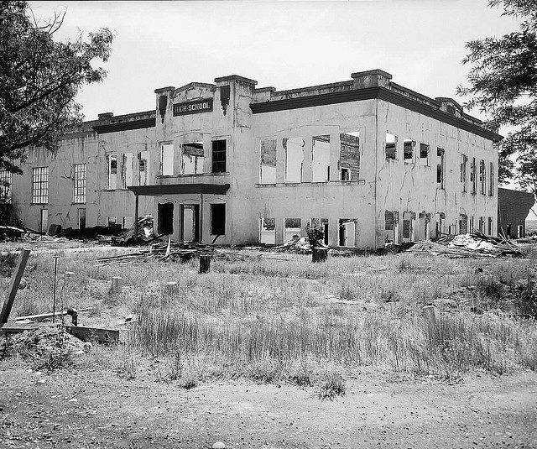

1954, Old Hanford High School
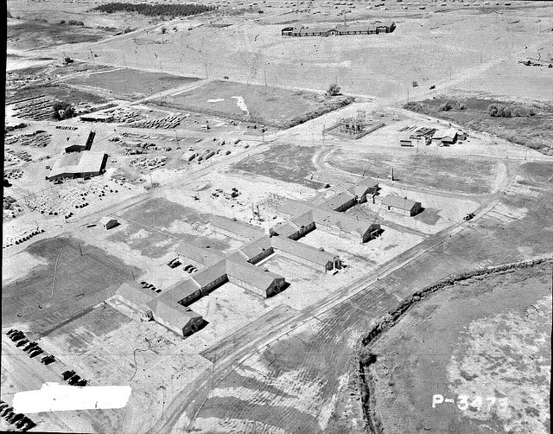

RICHLAND KADLEC HOSPITAL CONSTRUCTION
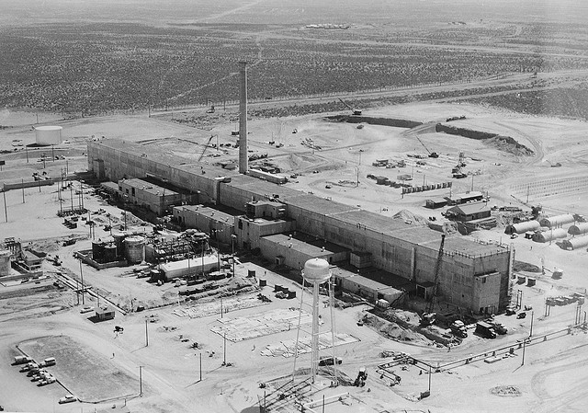

1954 PUREX PLANT (202-A) - ARMY GUN EMPLACEMENT TO THE WEST OF 2-EAST HILL, TOP OF PICTURE
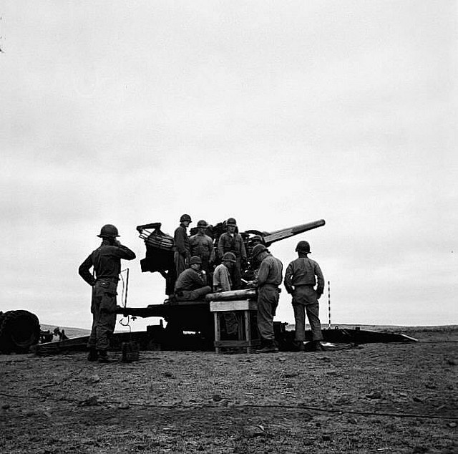

RADAR SCREEN AND GUN EMPLACEMENTS AT YAKIMA BARRICADE
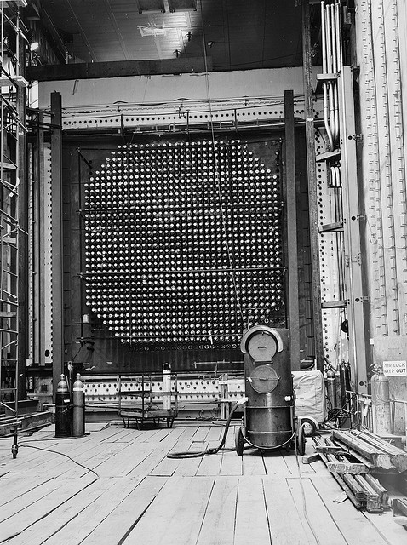

1962 THE FRONT FACE OF THE REACTOR WITH GUNBARRELS ON ENDS OF PROCESS TUBES
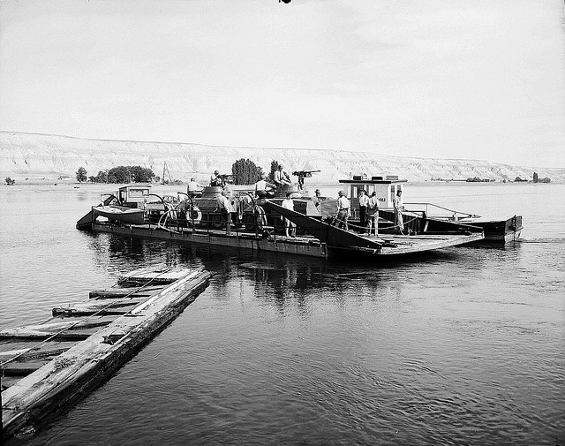

1949 HANFORD FERRY
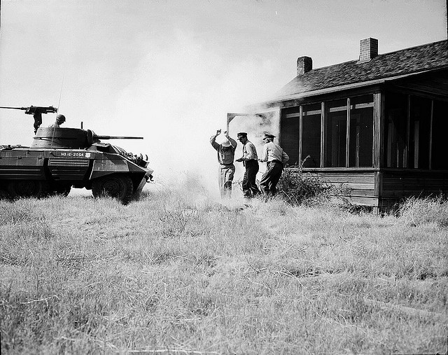

HANFORD SITE, PATROL EXERCISE, PHYSICAL PROTECTION AND SECURITY, TANK
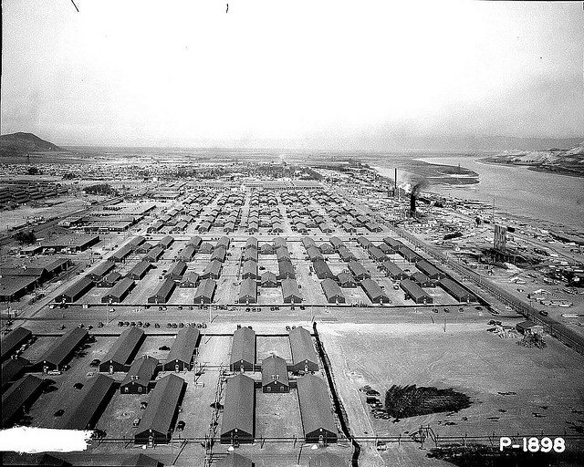

Camp Hanford 1944
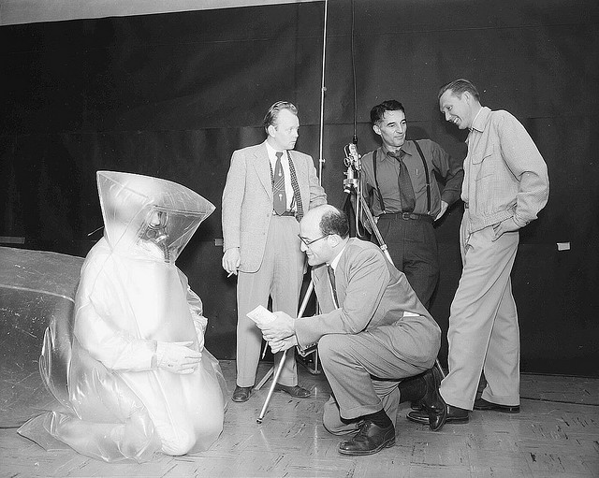

Photographing Plastic Man
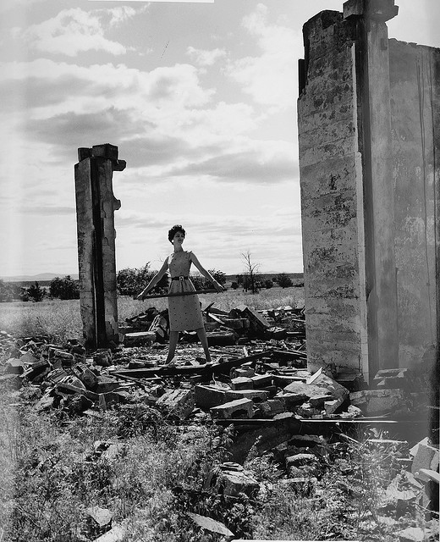

1965, Model in Remains of Old Hanford High School
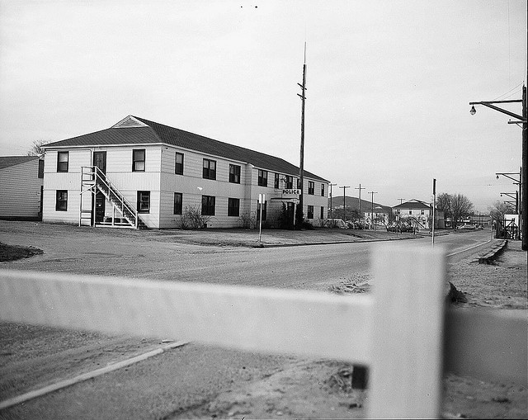

1952 POLICE BUILDING
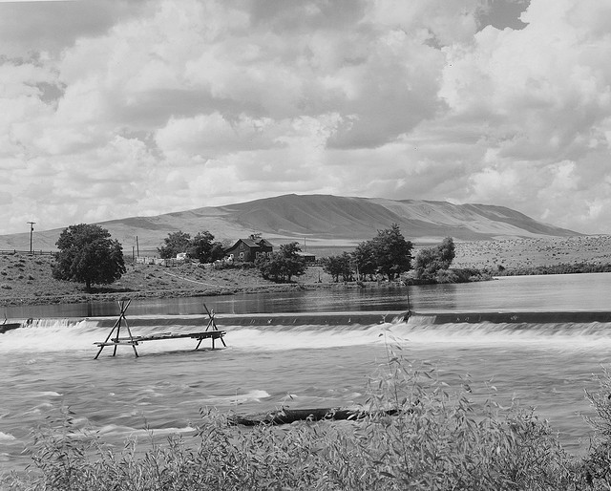

HORN RAPIDS, INDIAN FISHING PLATFORM
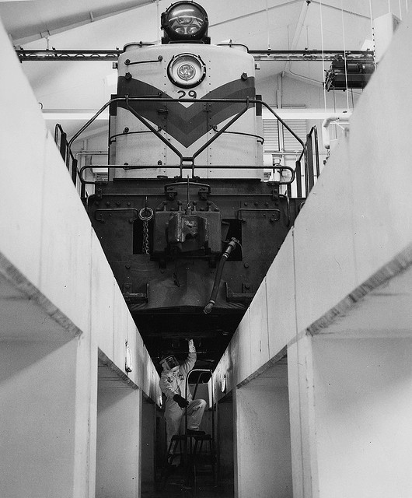

1960 LOCOMOTIVE BEING DECONTAMINATED
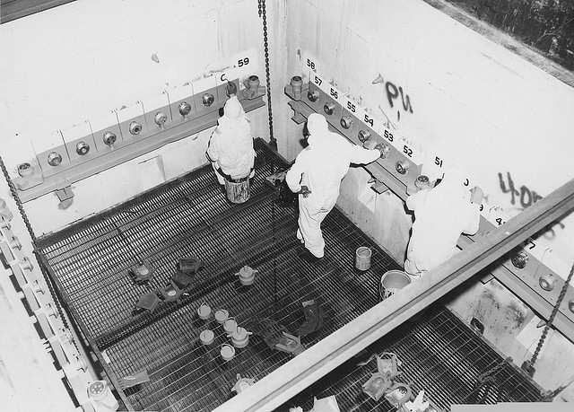

Painting Identification Cell 20, 1966
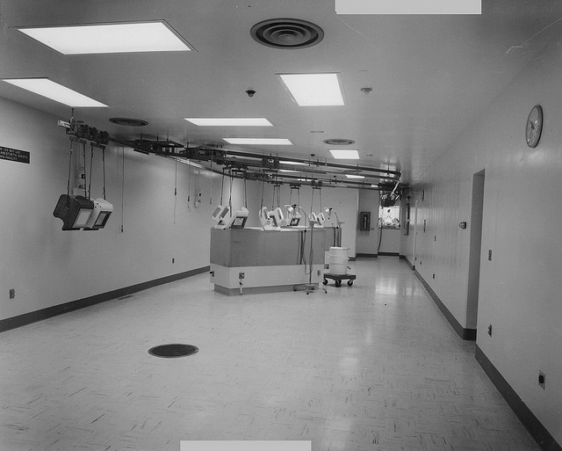

1970 DECONTAMINATION CENTER NEAR ORIGINAL KADLEC
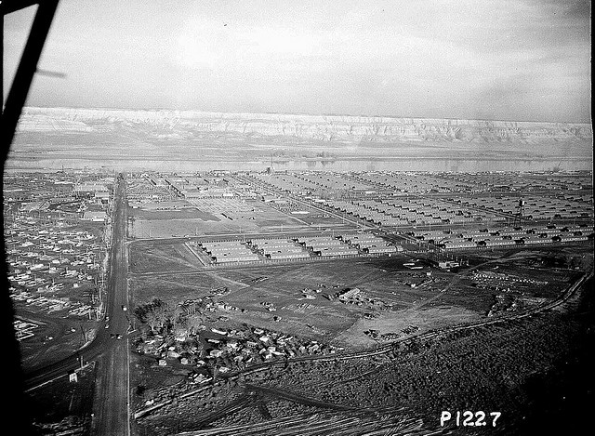

January 1944 HANFORD CONSTRUCTION CAMP (AERIAL LOOKING EAST AT WOMEN'S DORM AREA)
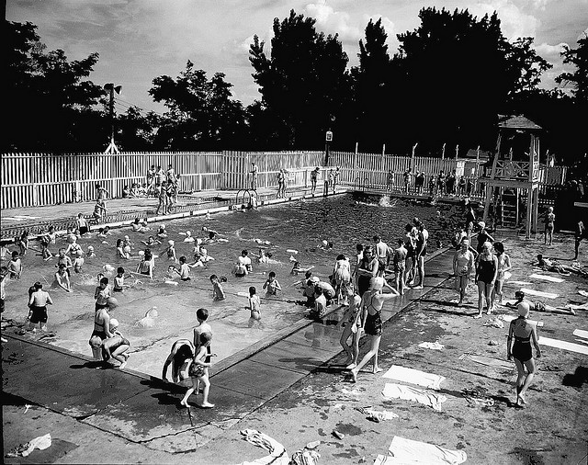

SWIMMING POOL BATHERS AT RIVERSIDE PARK - HOWARD AMON PARK
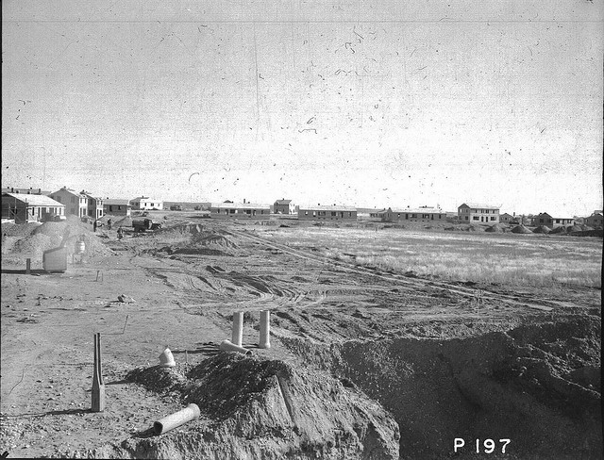

November 1943 RICHLAND #31 HOUSING AREA
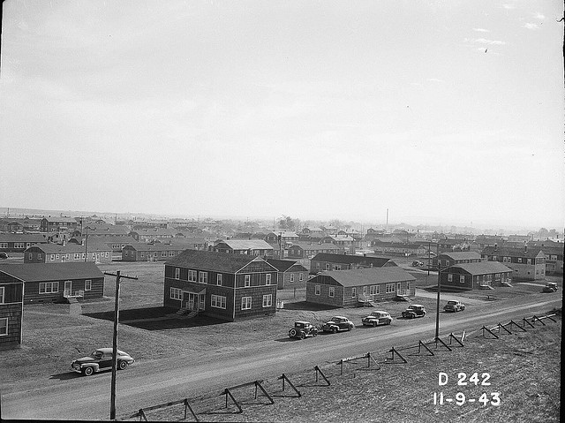

RICHLAND HOUSING - #27 HOUSING AREA
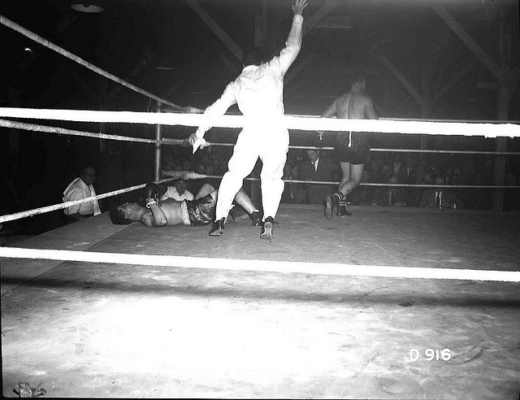

Boxing Match at Camp Hanford
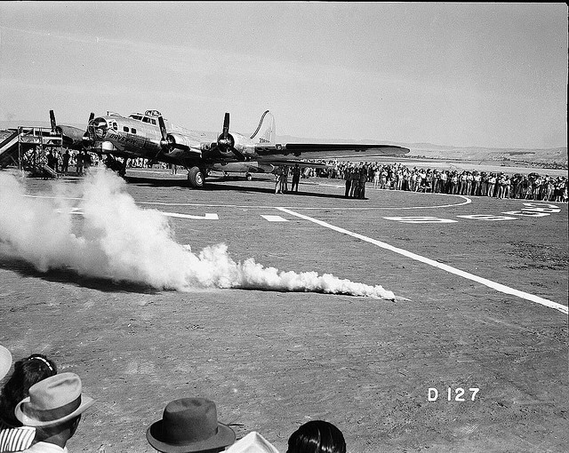

DAYS PAY WWII BOMBER
About 51,000 workers at Hanford each donated a day's pay, totaling about $300,000.00, for the purchase of a B-17 Bomber for the Army Air Force. Built by Boeing in Seattle, the plane was christened by Hanford workers on July 23, 1944 at a ceremony at the Hanford Airport.
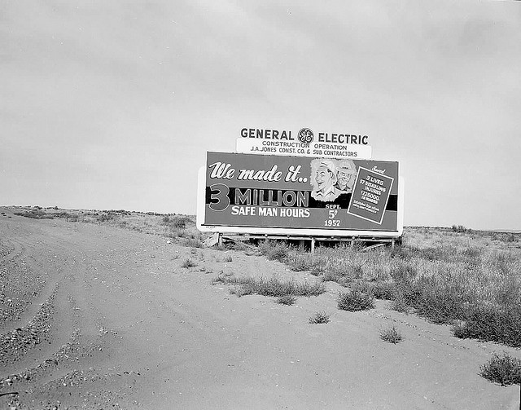

1957 SAFETY BILLBOARDS Number of Pages 1
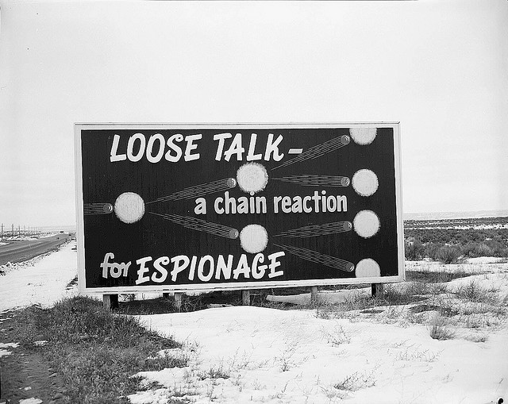

1954 SECURITY BILLBOARD ON AREA HIGHWAY
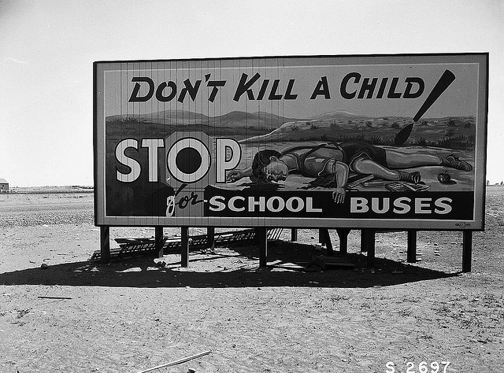

SAFETY BILLBOARD
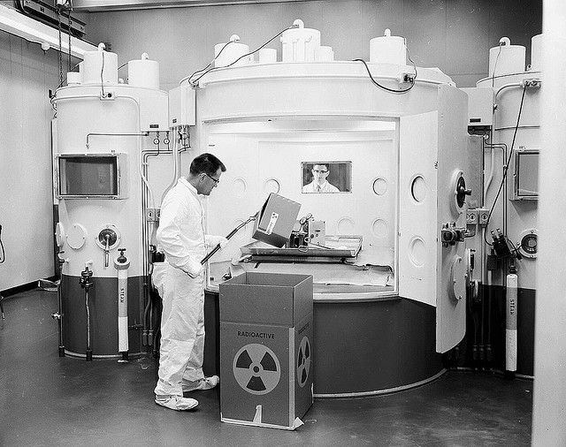

1954 DECONTAMINATION CELL AT RADIO MET - 327 BUILDING
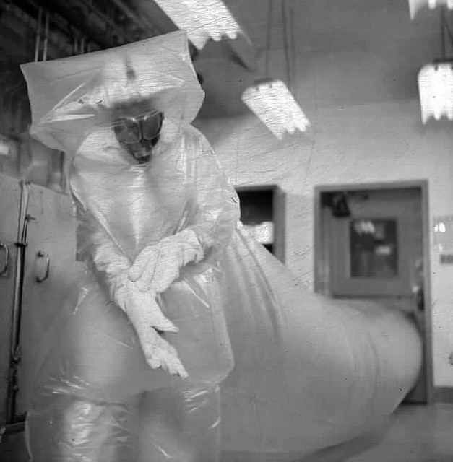

1954 PLASTIC MAN - 231 BUILDING, 200-W
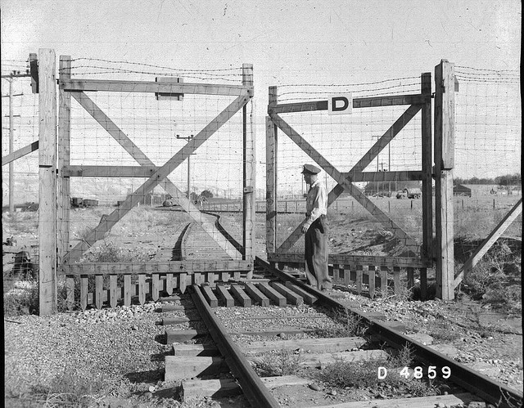

PATROL OPERATING RAILROAD ACESS GATE #D
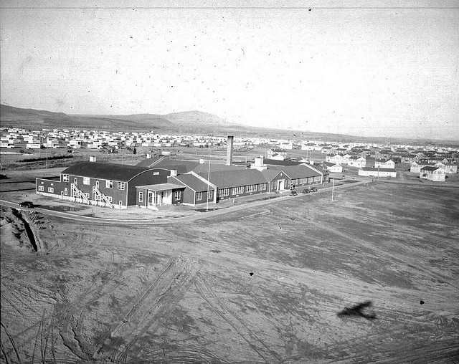

1945 RICHLAND HIGH SCHOOL
