IN MEMORY OF SONJA P. HARMON

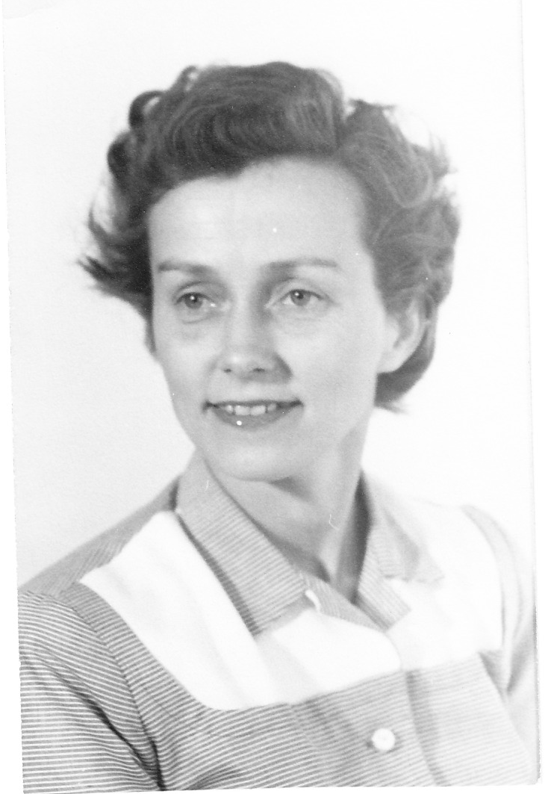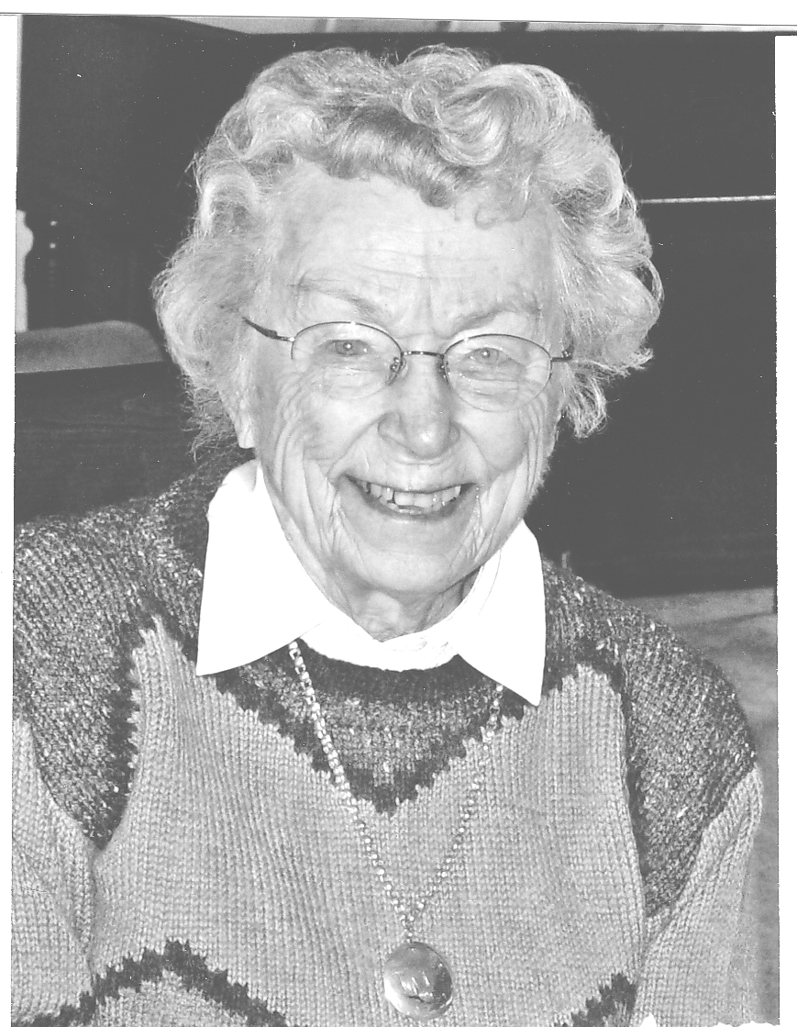

The remarkable life of Sonja Harmon came to an end on August 16, 2010. Sonja often said that she did not want to live a long time, and to the amusement of family and friends, she repeated that assertion when she turned ninety-three in February even though she was still quite vigorous, interested in world events, and generally upbeat. At the end of May, however, she got a surprise diagnosis of cancer and a pulmonary embolism. After refusing further medical intervention, she awaited death at her residence in Seattle with a mix of satisfaction, impatience, and ardent gratitude for the many blessings that life had bestowed on her.

Named Sophia Xenia Alexandrovna Petrovska at birth, Sonja was the third child of Russian immigrants Olga Mamchitz and Alexander Petrofsky, who had settled in Saginaw, Michigan. Although she considered herself thoroughly American, Sonja retained her Russian language and spoke of her parents' cultural heritage with pride. In later years she idealized her father, who died when she was seven; she was thankful for support from her stepfather, Osip Achkasov; and she revered her wise, kindhearted mother. Sisters Mamie and Clara died in the 1970s and 2007 respectively. A beloved brother, Mitchell Ackerson, survives, and his weekly phone calls from Vermont, with reports on his daughter and grandchildren, were a source of joy for Sonja until the end.

From the start, Sonja (called Sophie until her late teens) was a lively one -- active, athletic, curious, and outgoing. Her passion and aptitude for learning were apparent by age three, when she repeatedly ran off to kindergarten and was finally allowed to stay. She took lifelong pleasure in helping others to learn. Her forty-five-year career as a classroom teacher began in a one-room, rural Michigan school when she was just seventeen. For the two decades before her retirement, Sonja taught French and Russian at high schools. Though less than five feet tall, she had a seemingly natural ability to command students' respect and inspire hard work without demanding it. No one wanted to disappoint her. By all possible measures, she was a superb, highly effective, popular teacher who reveled in her students' achievements both during and after their time in her classroom. Many of them delighted her by keeping in touch years later.
In her last decades, Sonja often wondered aloud why she had been fortunate and favored in so many ways. To all who would listen, she declared repeatedly that among the greatest of her blessings was a very happy, sixty-three-year marriage to a "wonderful" man. Sonja met Merle Harmon on a tennis court and became his wife on June 13, 1942. Just out of chemistry graduate school Merle was "drafted" into the Manhattan Project. That work took the couple briefly to Chicago and Oak Ridge, Tennessee, before sending them across the country to Richland, Washington. There Merle was employed for thirty-six years as a chemical engineer and manager at the Hanford Atomic Works. After he retired, Sonja and Merle relocated to scenic Whidbey Island in western Washington, where they enjoyed just over twenty years of good health, material comfort, and socializing with old and new friends. Merle's physical decline prompted a move to Seattle in 2003 and took his life in 2005.

Mutual respect, trust, and enduring romantic love made the marriage exceptionally harmonious. (Merle -- an incorrigible punster -- would have liked that play on words.) But the happiness that Sonja sometimes attributed to good luck and to Merle's virtues also owed a great deal to her affectionate nature, positive energy, frankness, good sense, and many domestic skills. Sonja became an outstanding cook, interested in trying new dishes and renowned especially for her delectable pies, cookies, jam, and syrup. She sewed many of her clothes, knitted countless sweaters for herself and others, produced stunning needlepoint art, and then moved on to making quilts for her home, for relatives and friends, and for hospital fundraisers. She and Merle were also gracious hosts who relished visits from their many treasured friends.

According to Sonja, her one child -- daughter Alexandra (nicknamed Sandy and then Sasha) -- was "easy" to raise. According to Sasha, Sonja was as good a mother as they come -- consistently loving, fair, encouraging, and a model of integrity. Sasha's academic successes and eventual careers as an attorney and professor of American Indian history made Sonja exceedingly proud. It gave her added satisfaction that Sasha, too, became a happily married wife and mother. Sonja rejoiced that her son-in-law Jim Douglas provided legal services to needy people and kept busy as well with an array of volunteer service activities, sports, and music-making. She and her grandson Owen Douglas, who also found a calling as a school teacher, had a special bond that was strong and joyful. Sonja became so fond of former student Kathy Baird that she referred to Kathy as her foster daughter.

Friendly, warm-hearted, vivacious, smart, frank, unpretentious, principled, always a problem solver, and interested in so much of what life had to offer, Sonja Harmon expected the best of others and usually knew how to bring it out. Hers was a life splendidly lived -- a life for which many, many other people have had reason to give thanks.

